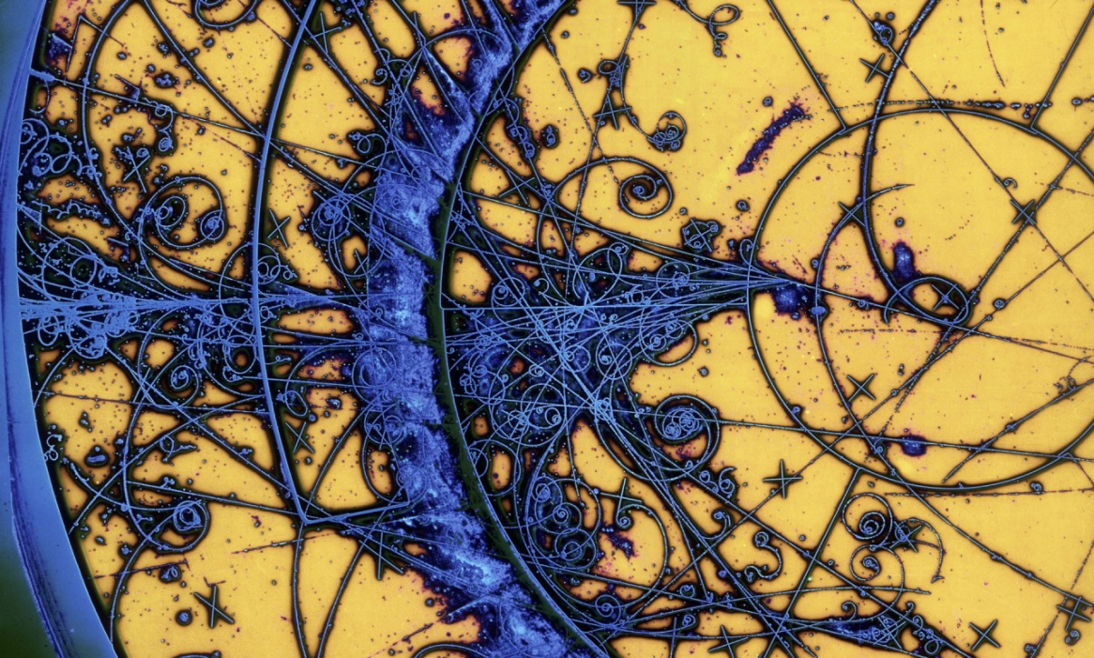

Institute of Physics- Frontiers of Physics 2015
Annual Conference for ALL Teachers of Physics,
including Junior Science Teachers
Saturday 19th September.
School of Physics
NUIG Galway
This year’s Institute of Physics teachers Conference takes place in NUIG. It will be a day of lectures, demonstrations, and workshops, resources and networking for all teachers of physics including Junior Science Teachers.
The keynote presentation will be delivered by the eminent physicist and author Prof. Frank Close OBE, FinstP, Exeter College, University of Oxford.
There will be other guest presenters and a series of ‘Showcase Talks’ from NUIG.

Workshops will include:
The recently returned from London, Irish Science on Stage Team
Go photon-celebrating International Year of Light

A discussion will take place on the LC 2015 Physics papers and marking schemes, which will form the basis of the Institute of Physics report to the SEC.
See www.iopireland.ie for more details

