Top Leaving Certificate Chemistry Student 2013

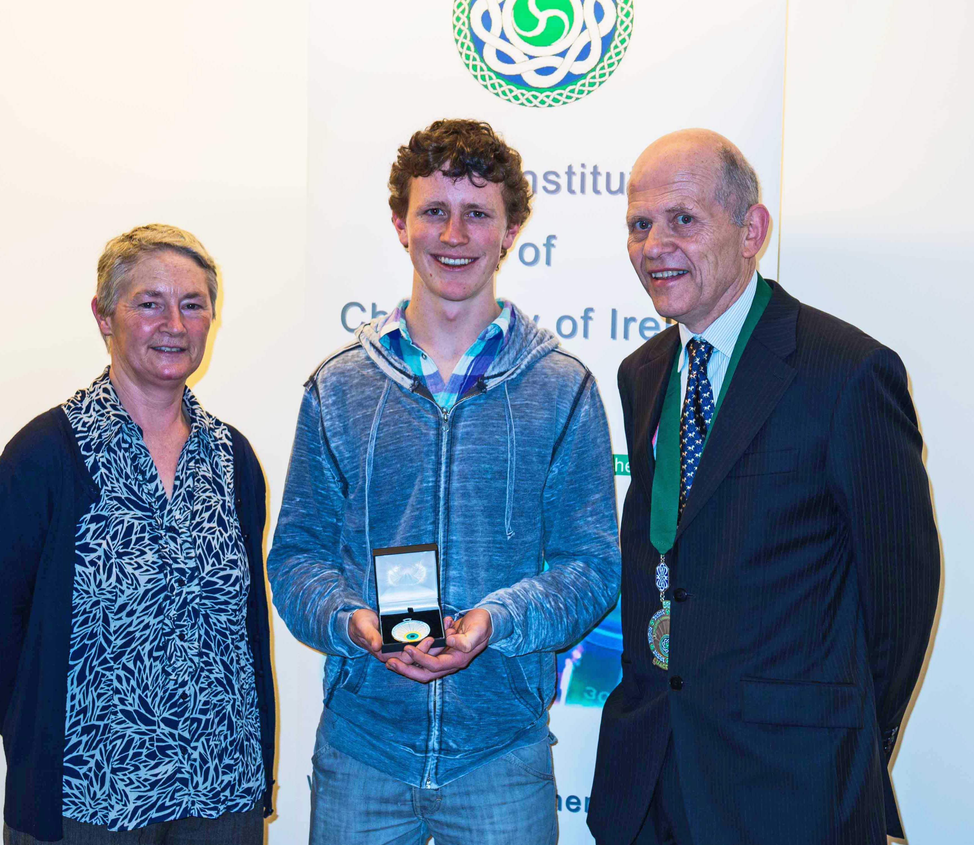
Presentation of The Institute of Chemistry of Ireland Medal to top 2013 Leaving Certificate Chemistry Student.

Kyle Frohna, St Andrews College, Blackrock, Co Dublin, with Hilary Rimbi (Chemistry Teacher) and Pat Hobbs FICI (Institute President)
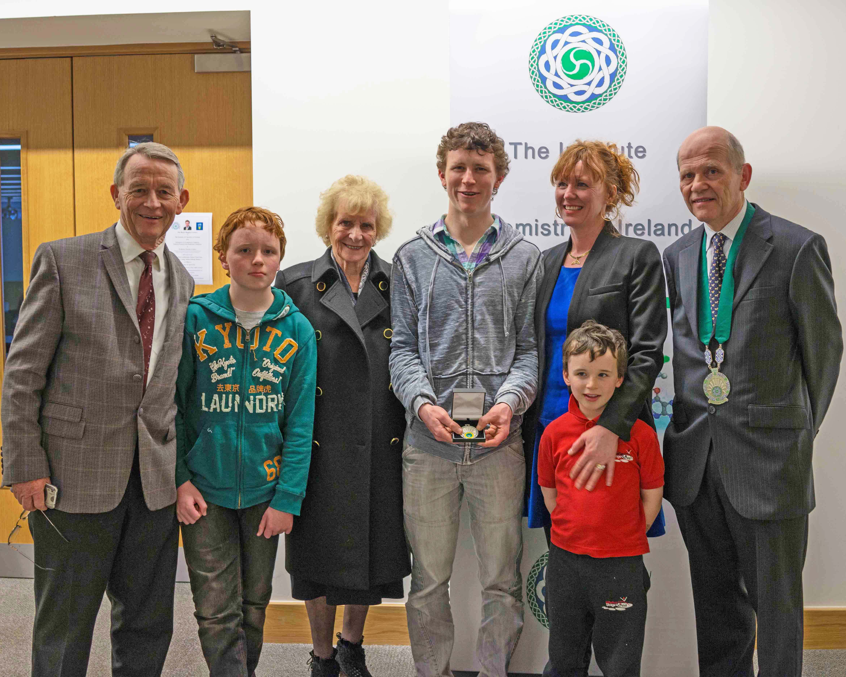

Kyle Frohna with members of his family, receiving the 2013 Institute Medal from Pat Hobbs FICI (Institute President)

