Schools Chemistry Newsletter Prize 2015/16
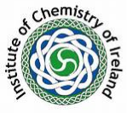
Celebrating The International Year of Light 2015
First Prize: €100  sponsored by  The Institute of Chemistry of Ireland  Irish Chemical News, the journal of The Institute of Chemistry of Ireland, may consider publishing articles from the winning newsletter.  Extracts may also be circulated with Chemistry in Action.  Two runners up prizes: €50 each  The competition is supported by the  Irish Science Teachers’ Association  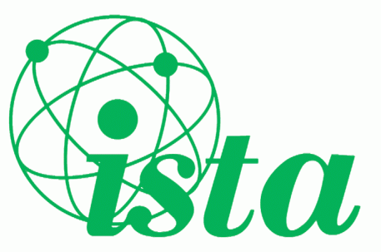 | - This competition is open to all second level students, including transition years, interested in Chemistry (both North and South).  - Only individual entrants are allowed.  - Students should submit a Newsletter on the theme of “Chemistry and Light”, suitable for the non-scientist, outlining clearly and accurately any aspects of the topic in an engaging, informative and easily readable manner.  - The newsletter should consist of four A4-sized pages.  - Sources of information must be cited (four maximum)  - The name and contact details of both the student and teacher including the school name should be clearly stated.  - The entrants are strongly encouraged to use good quality graphics/photographs to illustrate their newsletter.  - An electronic Microsoft Word file should be submitted as an email attachment to: info@instituteofchemistry.org  - Closing date is Friday, 29th December 2015.  - Failure to abide by rules will mean automatic disqualification.  The Institute of Chemistry of Ireland will nominate an adjudicating panel. Strict adherence to the guidelines will be taken into account when assessing each newsletter.  Winning students will be contacted and awarded their prizes at the ChemEd Conference, which will be held in DCU on Saturday 15th October 2016 (date to be confirmed)

