ISTA Senior Science Quiz Regional Final Finals
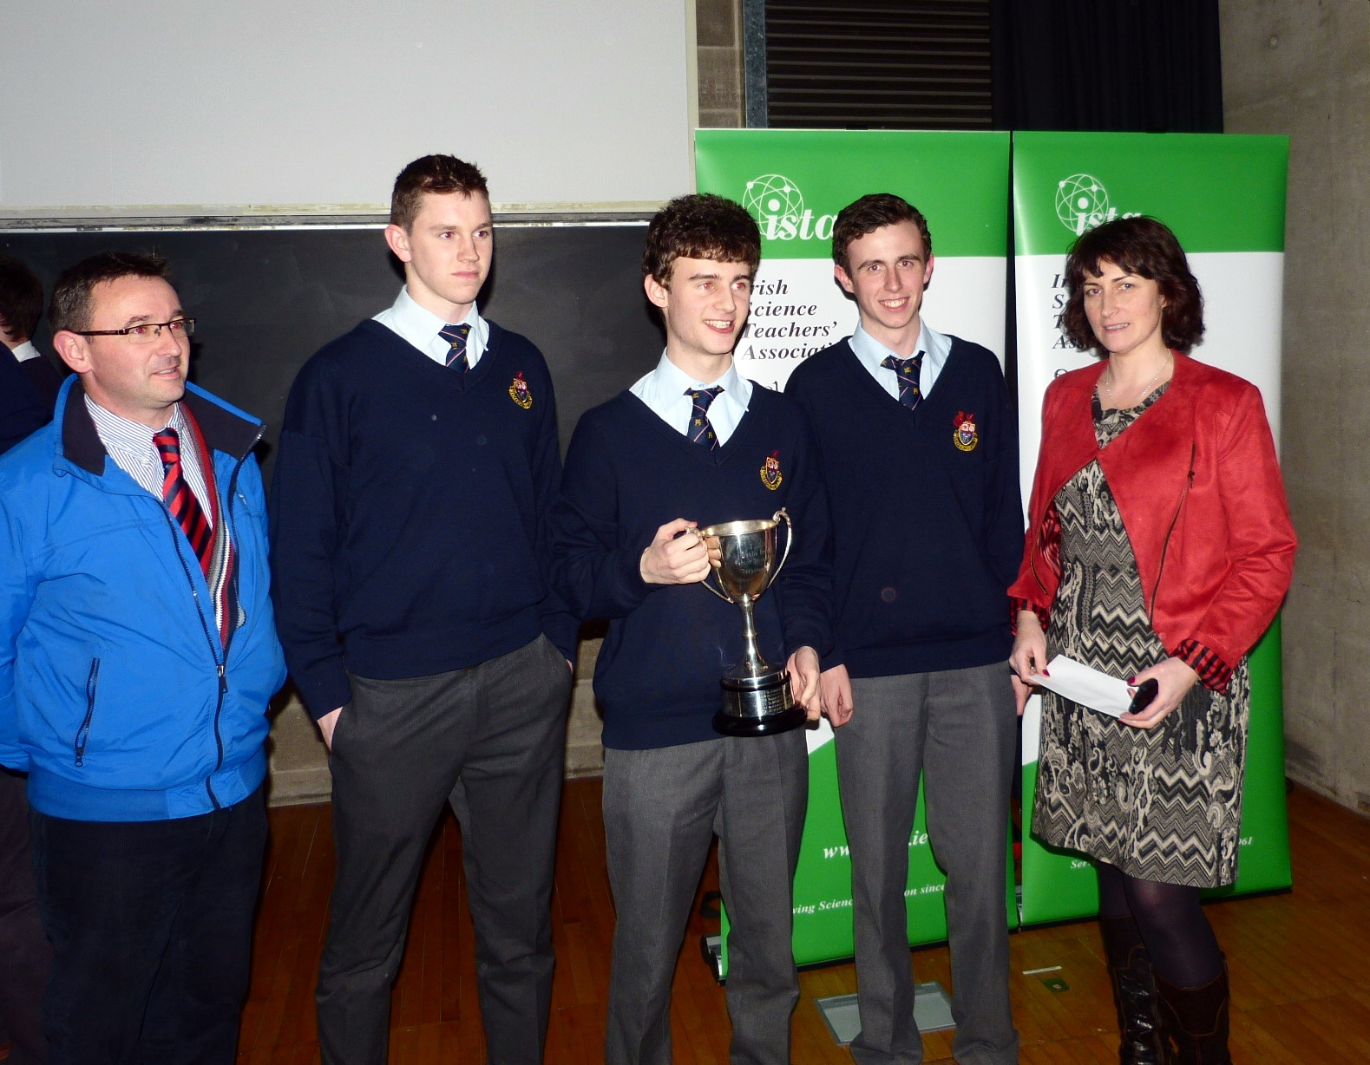

1st Wesley College

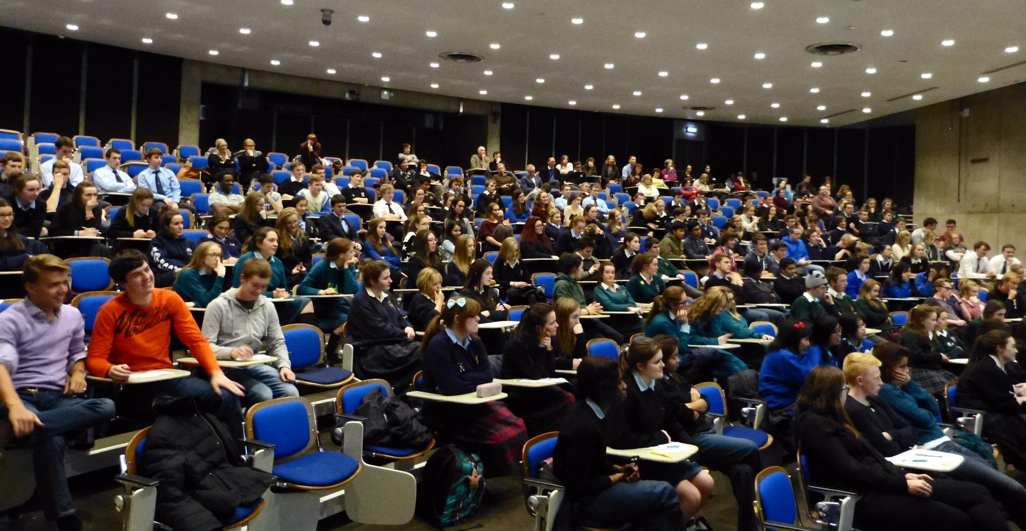
- Wesley College
- Mount Anville
- St Michael’s College
- Belvedere College
- St Gerard’s Bray
- Sandford Park
- Blackrock College

Thanks to the Dublin Branch of ISTA who helped to coordinate the event.
Thanks to Dr Shane Bergin for his inspiring talk & Trinity College for the venue. Last but not least thanks to the teachers and the teachers who attended and made it a pleasurable experience for all.

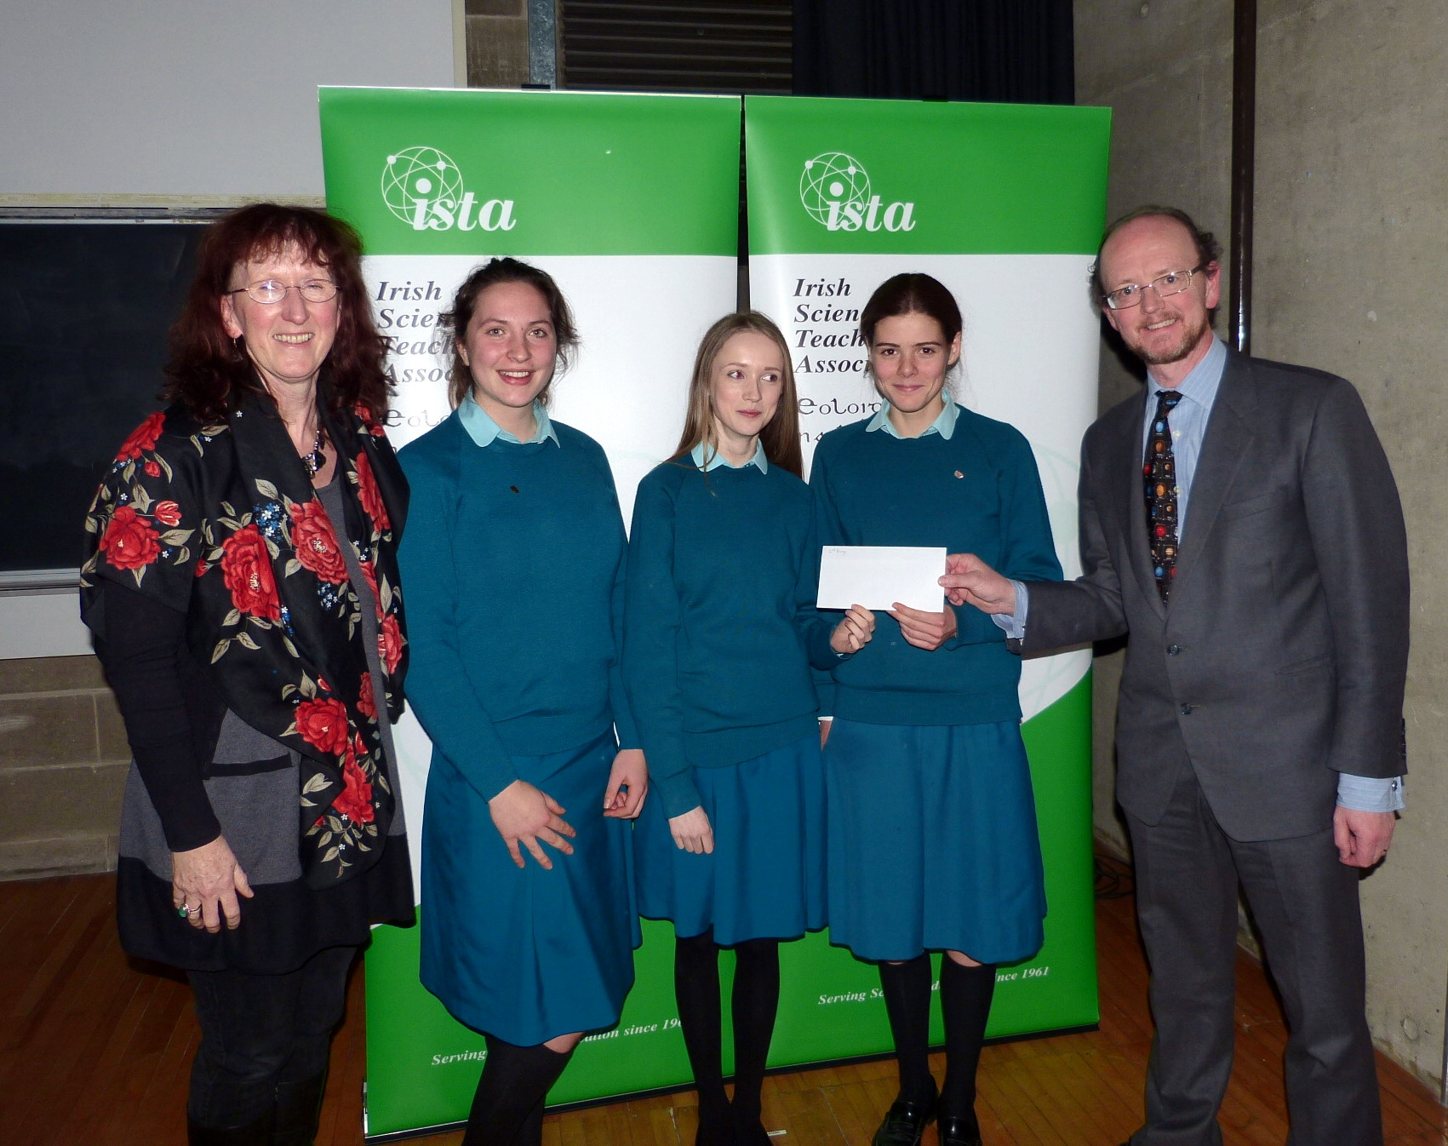
2nd Mount Anville

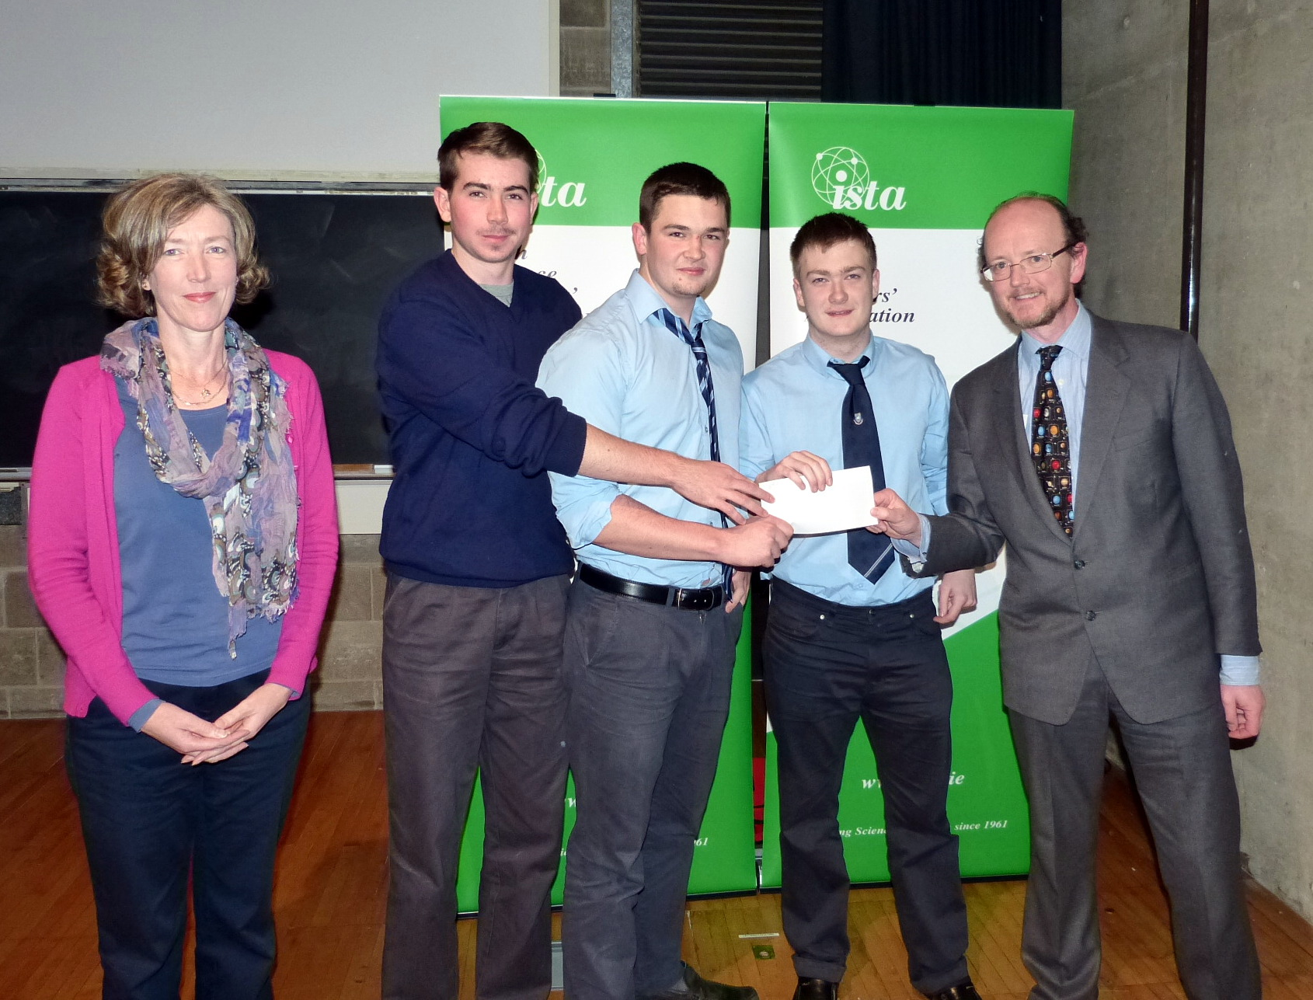

3rd St Michael’s College

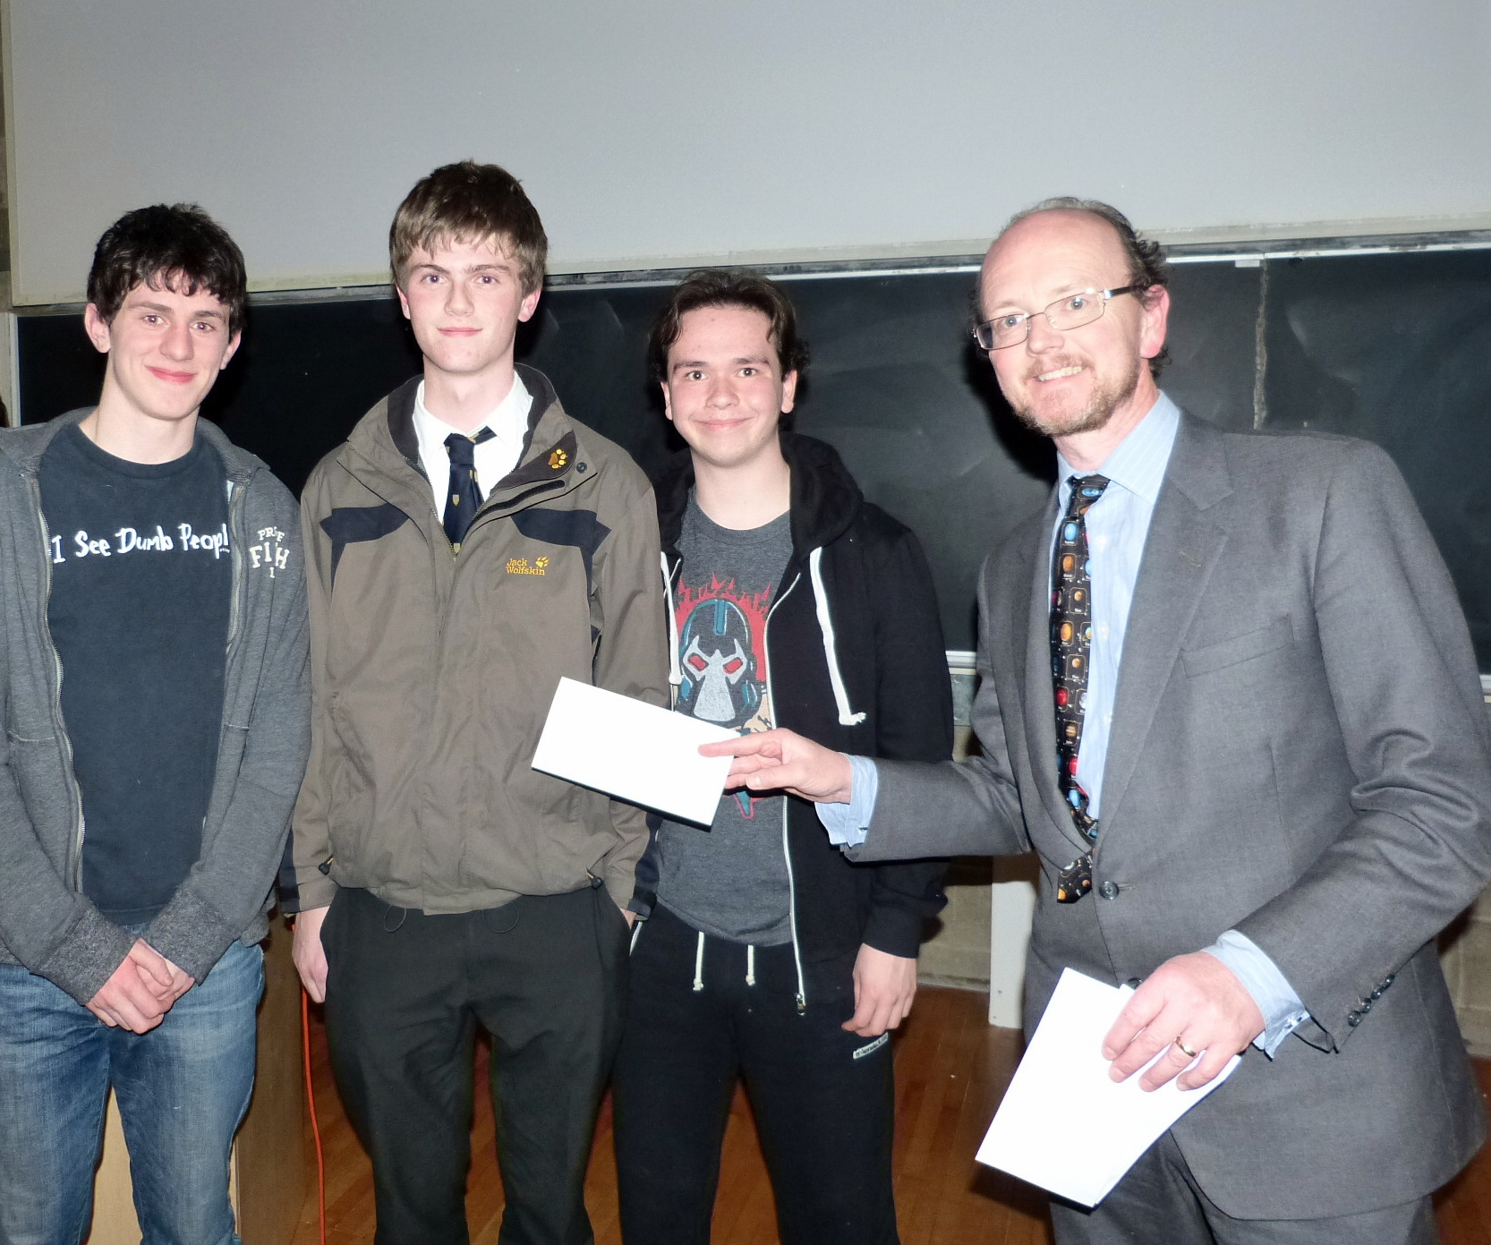

4th Belvedere College

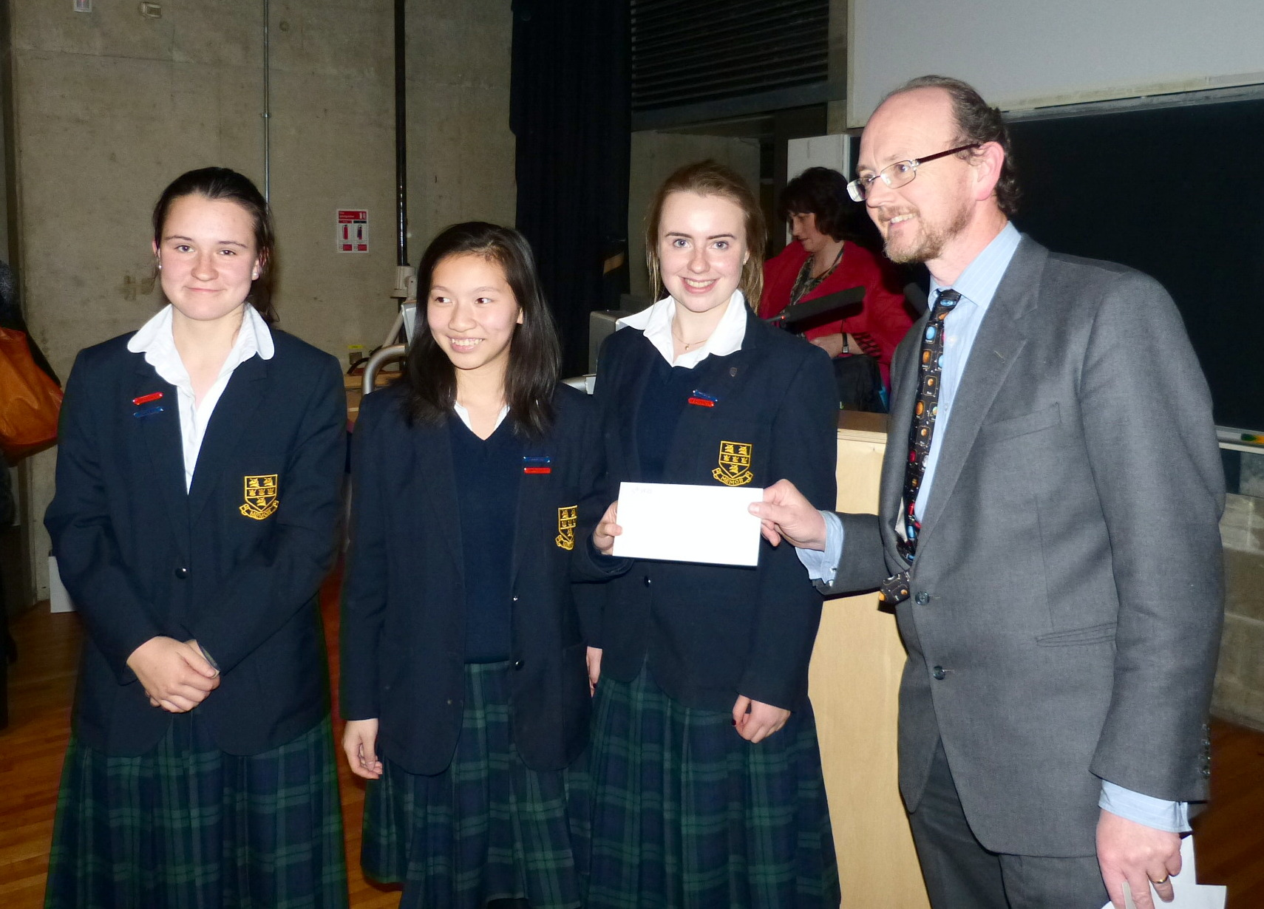

5th St Gerard’s College
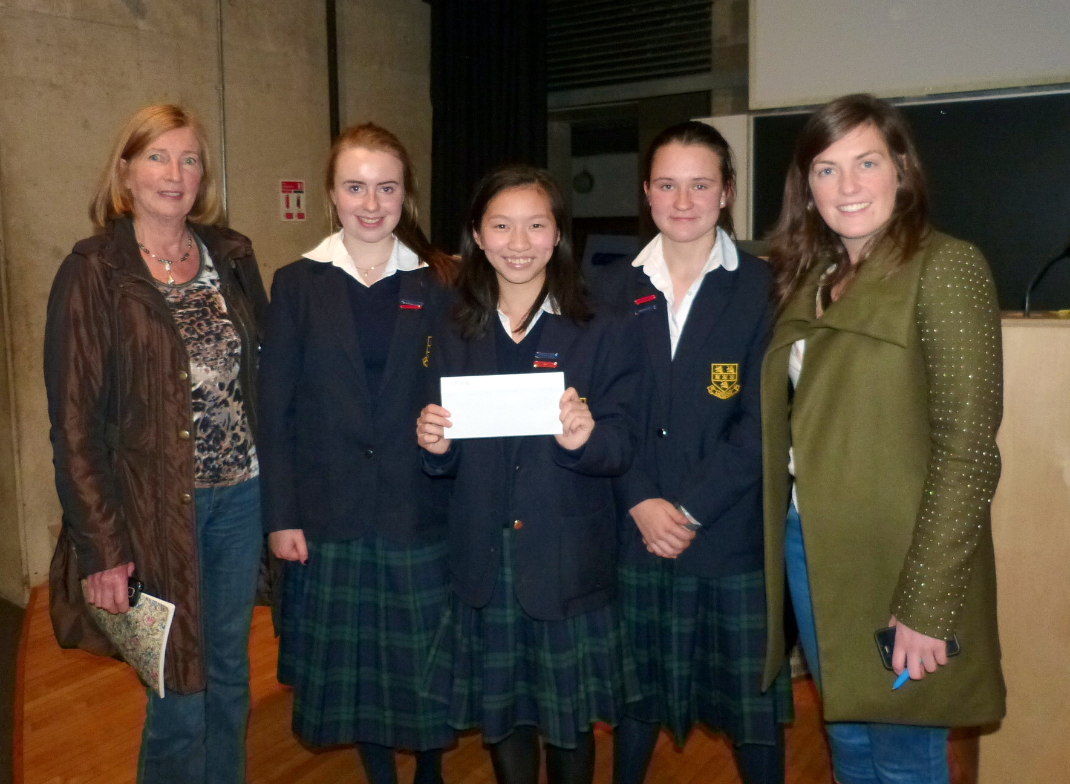

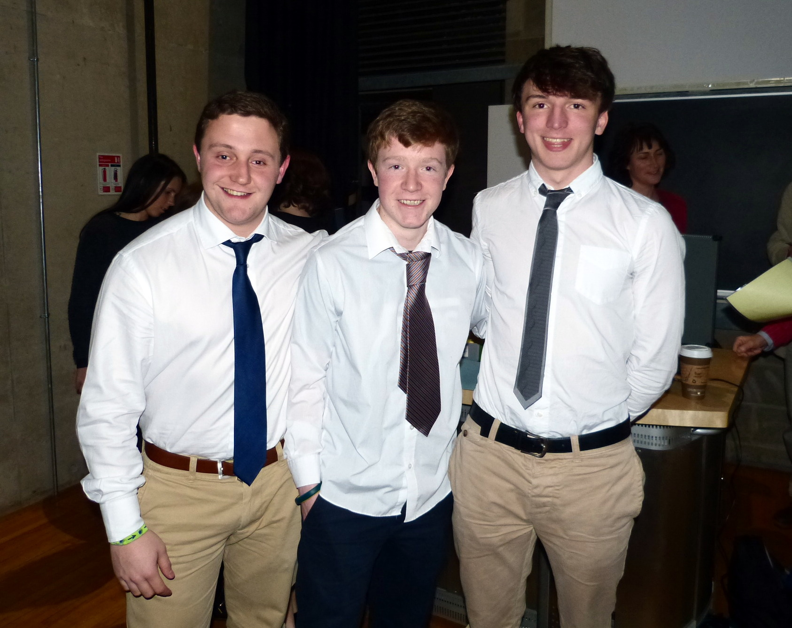
7th Blackrock College

