Kildare Branch ISTA Senior Science Quiz

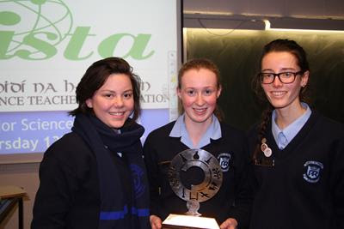 | 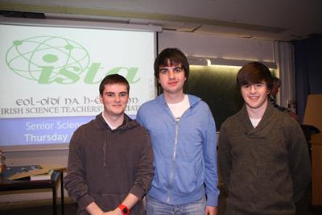
Eureka Secondary School | Clongowes Wood College
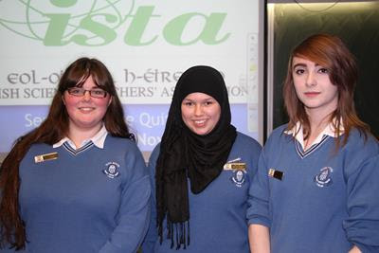 | 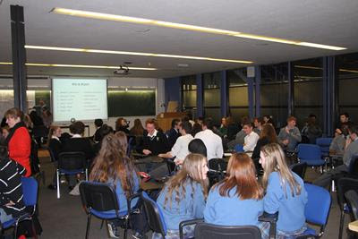
Scoil Mhuire Trim | NUI Maynooth

