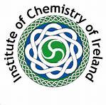

Schools Chemistry Newsletter Prize 2014/15

First Prize: €100  sponsored by  The Institute of Chemistry of Ireland  Irish Chemical News, the Journal of, The Institute of Chemistry of Ireland, may consider publishing articles from the winning newsletter.  Extracts may also be circulated with Chemistry in Action.  Runners up: €60 each  The competition is supported by the  Irish Science Teachers’  Association  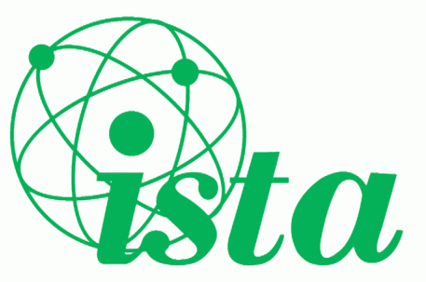 | This competition is open to all second level students, including transition years, interested in Chemistry (both North and South).  Students should submit a Newsletter on the theme of “Crystallography”, suitable for the non-scientist, outlining clearly and accurately any aspects of crystallography in an engaging, informative and easily readable manner.  The entrants are strongly encouraged to use good quality graphics/photographs to illustrate. Sources of information should be cited.  The Institute of Chemistry of Ireland will nominate the adjudicating panel. Strict adherence to the guidelines will be taken into account when assessing each newsletter.  The name and contact details of both the student and their teacher including the school name should be clearly stated.  Four printed copies of the Newsletter (each consisting of 4 single-sided A4-sized pages) and one Microsoft Word electronic attachment should be sent as follows:  Submit the printed Newsletters to:  The Institute of Chemistry of Ireland,  PO Box 9322, Cardiff Lane, Dublin 2.  Submit the electronic Microsoft Word copy  to: info@instituteofchemistry.org  The closing date is  Friday, 10th April, 2015.  Winning students will be contacted and awarded their prize at the ChemEd Conference, which will be held in UCC on Saturday 17th October.

