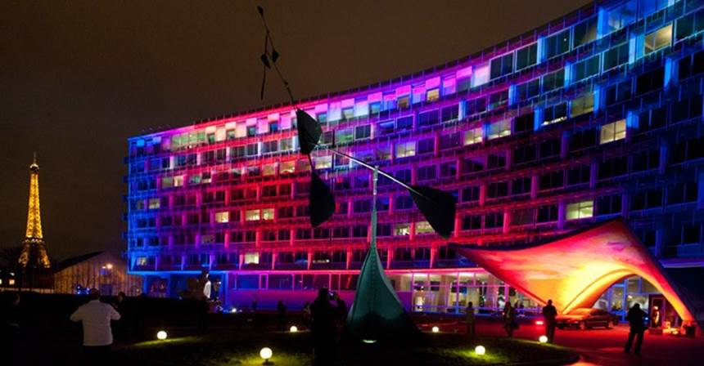
The UNESCO BUILDING lit up for the LIGHT2015 launch.

UNESCO International Year of Light 2015

LIGHT2015 got off to a great start with a launch at the UNESCO building in Paris on Monday 19th and 20th January. We had presentations from Nobel Laureates and ministers, students and NGOs, officers of UNESCO and educators. As we listened to the original compositions for the upcoming movie, “Einstein’s Light”, played on a 1700’s Stradivarius by Grammy winner Joshua Bell, the irony that it followed shortly after one of the darker episodes in Paris was not lost on us. When soldiers replace the gendarmes on the streets of a civilized nation, we look to arts, education and knowledge to remind us that there is a better way to live. Light is perhaps the first recognizable constituent of the Big Bang and has come to symbolize discovery and progress in a universal way. For the believers, it is embodied in the enlightenment of Buddha as well as the separation of light from darkness in the Bible and Koran. Now as we have reached the limit of what we can do with electronics we need light, not only to illuminate, record and display images and video, but also to transmit this data such that a large portion of the seven billion people in the world can use and enjoy. Indeed, in many facets of our modern lives, the word ‘electronics’ is being replaced by ‘photonics’. Some examples include laser-based manufacturing and medicine, Internet data transmission, movies, entertainment and the arts.

More recently in San Francisco, I had the privilege to meet Shuji Nakumura who regaled us over lunch with several anecdotes from his life in physics. For example he accidentally started working on gallium nitride (GaN) as a substrate for LEDs because everybody else was using zinc selenide, which was thought to be an easier way to produce blue LEDS. He thought he would have no chance to publish sufficient work in zinc selenide to gain a PhD. It turned out that, despite its problems, GaN was the key to producing efficient blue LEDs and hence white light for space lighting. In the early 90s, phone manufacturers wanted blue light LEDs because other backlight sources required over 100 V which was too much for mobile applications. Indeed 2014 was a bumper year for physicists working on light. In December, Akasaki, Amano and Nakamura got the Nobel Prize for Physics for the development of efficient blue LEDS. Stefan Hell, Eric Betzig and William Moerner were awarded the Nobel Prize for Chemistry for overcoming diffraction to build super-resolution microscopes, allowing us to discover more about how life works at the sub-cellular level.

Here in Ireland we have a proud history of light engineering and physics. More than 5,000 years ago, before Stonehenge and the Egyptian Pyramids, Irish settlers built a giant light box at Newgrange. This light box illuminates the back of what we assume is a tomb once per year between 9 and 9.15 am on December 21st and, unlike my twentieth century watch, continues to work well. During the year we plan to have events at Newgrange and throughout the country to celebrate light.
We have launched educational apps to explore colours and heart rate, which Android phone users can download from the Google Play store by searching for ‘GoPhoton’. The code and documentation is available from martin.leahy@nuigalway.ie. Events and news for LIGHT2015 in Ireland will be listed on www.light2015.ie

2015 is an opportunity to share the benefits of light, to provide more civilized cancer treatments such as photothermal and photodynamic therapies and to help the remaining one billion people to have safe night lighting so that the children can do their homework. Let’s all work together to share the light!

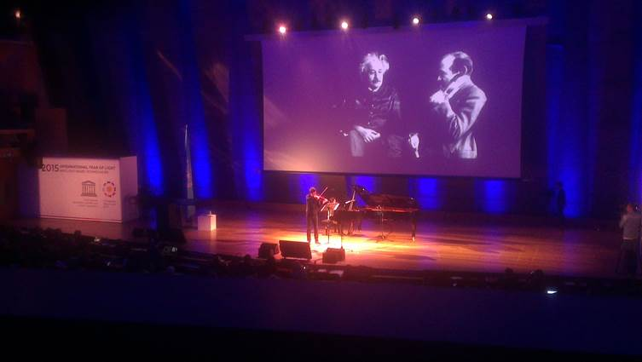
Grammy award winner Joshua Bell plays original compositions for ‘Einstein’s Light’.

