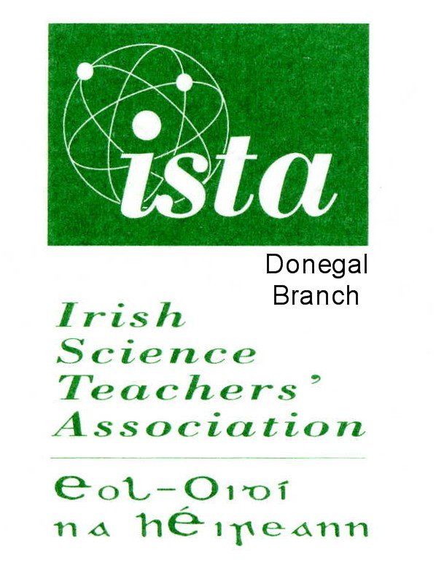
Application Form for Third
Level Membership of ISTA.

If you pay the subscription of €150 online using PayPal or a credit card at www.ista.ie/membership-join/ there is no need to complete this form as all your details have been entered by you in the system. Your membership is activated for one year starting on the day that you have completed registration.

This form need only be completed if you are paying via an invoice system of via a cheque. Your membership will be activated for one year as soon as payment is received from you.

NAME OF THIRD LEVEL INSTITUTION __________________________________________

ADDRESS OF THIRD LEVEL INSTITUTION ____________________________________

DETAILS OF CONTACT PERSON IN THIRD LEVEL INSTITUTION:

TITLE ________ NAME _______________________________________

E-MAIL ADDRESS OF CONTACT PERSON __________________________

MOBILE PHONE NUMBER OF CONTACT PERSON ___________________________
(You will be sent a text message by the local ISTA branch in case of last minute changes to scheduled events)

NAME OF BRANCH YOU WISH TO JOIN _____________________________
(The ISTA branches are: Cork, Donegal, Dublin, Galway, Kerry, Kildare, Kilkenny/Carlow, Limerick/Clare, North Midlands, Sligo, Tipperary, Waterford and Wexford).

Please indicate method of payment::
□ Payment by cheque. A cheque for €150 (made payable to ISTA) attached to this form may be posted to Dr Declan Kennedy, Department of Education, UCC.
□ Electronic Transfer. Payment of €150 has been made by electronic transfer to the following account:

Name of Account: Eol Oidi na hEireann
Name of Bank : Allied Irish Bank,
Address of Bank: 40/42 Ranelagh, Dublin 6.
Sort Code : 93-12-92
Account Number : 04811-025
BIC : AIBKIE2D
IBAN : IE34 AIBK 9312 9204 811025

Please email this completed form to: d.kennedy@ucc.ie and copied to briananthonyclarke@gmail.com Thank you for your support of the ISTA. It is very much appreciated.

INVOICE

Invoice No 140822

14/8/2022

Invoice address
[PLEASE INSERT THE NAME AND ADDRESS OF THE RELEVANT PERSON IN YOUR OWN INSTIUTION HERE]

Payment to :  Irish Science Teachers’ Association,  c/o Dr Declan Kennedy,  ISTA Membership Secretary  Department of Education,  UCC  Cork | For:  Annual Subscription for Third Level membership of Irish Science Teachers Association

DESCRIPTION | AMOUNT
Annual subscription for Third Level Membership of Irish Science Teachers’ Association | €150.00
TOTAL | €150.00

Payment may be made by one of the following methods:

(i) Electronic Transfer. Payment may be made by electronic transfer of €150 to the following account:

Name of Account: Eol Oidi na hEireann.
Name of Bank : Allied Irish Banks,
Address of Bank: 40/42 Ranelagh, Dublin 6.
Sort Code : 93-12-92
Account Number : 04811-025
BIC : AIBKIE2D
IBAN : IE34 AIBK 9312 9204 811 025

(ii) Payment by cheque. A cheque for €150 (made payable to ISTA) may be forwarded to Dr Declan Kennedy, Department of Education, UCC.

